What is CodeIgniter-4?

**CodeIgniter-4**, a PHP framework which provides a standard way to write efficient, clean and easily understandable code. Basically it is used for creating full featured web based applications.

Why CodeIgniter-4 is preferable?

As we know there are some other PHP frameworks so why should we prefer using CodeIgniter-4 over other PHP frameworks? Because there are some reasons which make CodeIgniter-4 unique such as simple configuration, lightweight and efficient, built-in security function, clear and structured documentation, and fast development process, big and active community support etc.

Installation process using XAMPP

There are several processes of installation. Here I am going to use XAMPP as an open source cross platform web server which contains MariaDB, PHP and Perl. If your system doesn’t have you may download from [here](https://www.apachefriends.org/index.html) based on your operating system and install it. Now, download CodeIgniter-4 from the official [website](https://codeigniter.com/download).

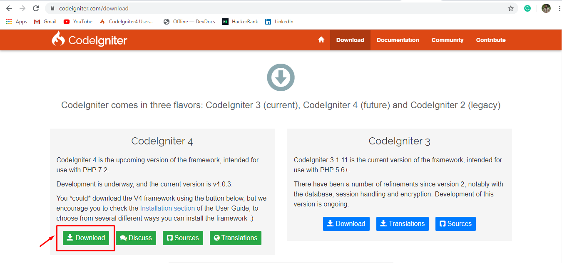

After downloading the codeigniter-4, Go to the htdocs folder. Let, you are installed xampp on Local disk D so you should be able to find htdocs folder on your Local disk D under xampp folder (D:\xampp\htdocs). Now create a folder under htdocs and give it a name such as codeigniter then paste all the extracted files from “framework-4.0.3.zip” which downloaded before.

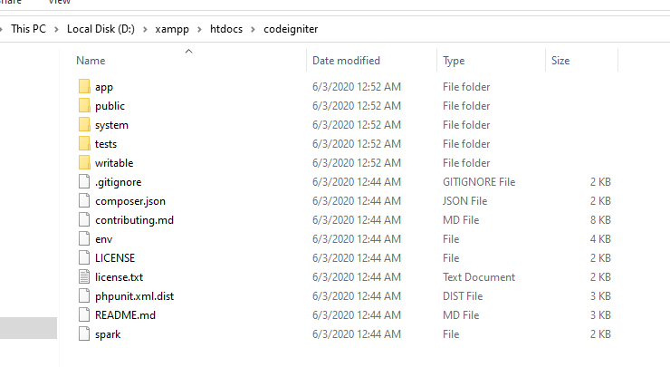

Open XAMPP and click start button to active Apache and MySQL.

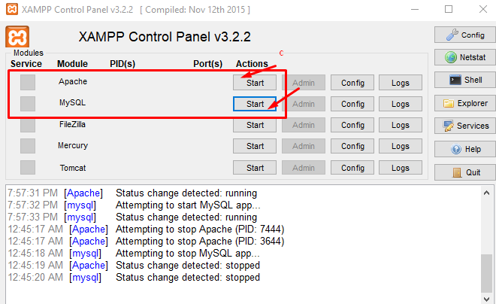

Now open your browser and type : <http://localhost/codeigniter/public/> .You will be show this page

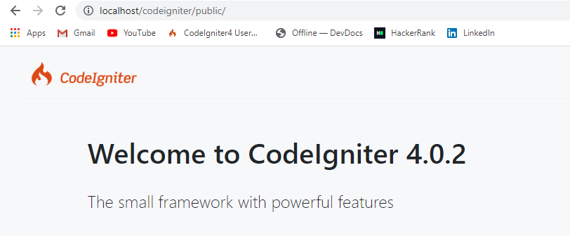

Congrats! Finally you have done it ! Thank You.